Cyber Security Task 2
SOC Alert Monitoring & Incident Response Simulation
By: Mersilin Princy M – Internship at Future Interns

1. Introduction
In this task, I simulated the role of a Security Operations Center (SOC) analyst. The main goal was to monitor security alerts, identify suspicious activities, classify alerts by priority, and draft incident responses. This exercise helped me understand how SOC teams detect threats and respond to incidents in real-time.

2. Sample Alerts
Timestamp | User | IP | Action | Threat
2025-07-03 09:10 | Bob | 172.16.0.3 | Malware Detected | Ransomware Behavior
2025-07-03 07:51 | Eve | 10.0.0.5 | Malware Detected | Rootkit Signature
2025-07-03 07:45 | Charlie | 172.16.0.3 | Malware Detected | Trojan Detected
2025-07-03 05:48 | Bob | 10.0.0.5 | Malware Detected | Trojan Detected
2025-07-03 04:41 | Alice | 172.16.0.3 | Malware Detected | Spyware Alert
Note: These are the most critical alerts I identified from the provided logs.

3. Alert Classification
High Priority:
- Bob – Ransomware Behavior
Medium Priority:
- Eve – Rootkit Signature
- Charlie – Trojan Detected
Low Priority:
- Other minor malware alerts

4. Incident Response Report
Timeline of Key Events:
- 04:41 AM – Spyware detected on Alice’s machine
- 05:48 AM – Trojan detected on Bob’s machine
- 07:45 AM – Trojan detected on Charlie’s machine
- 07:51 AM – Rootkit detected on Eve’s machine
- 09:10 AM – Ransomware detected on Bob’s machine
Impact Assessment:
- Multiple malware alerts detected on user machines
- Potential data compromise and unauthorized access
- Immediate attention required to prevent spread
Remediation Steps:
- Isolate affected devices from network
- Run full malware and antivirus scans
- Reset compromised accounts and passwords
- Update security software and firewalls
- Monitor for further suspicious activities5.Screenshots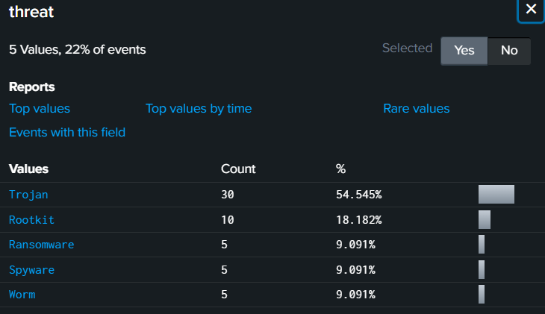
These percentages help visualize which threats are most prevalent and allow prioritization of incident response efforts.

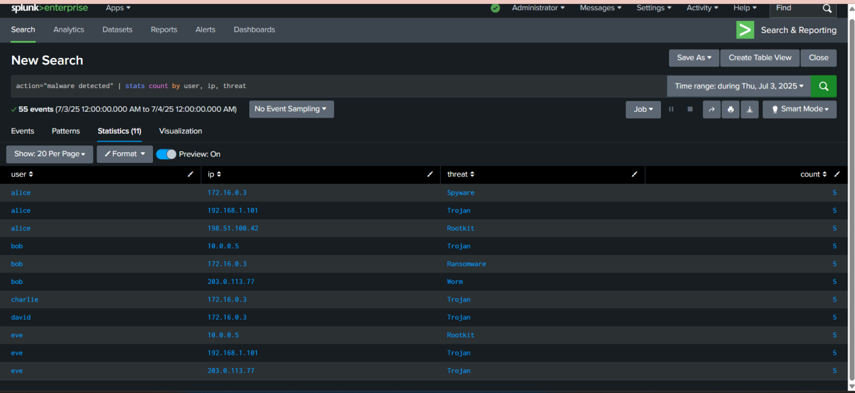
The malware detection count highlights a significant risk to network security, prompting immediate investigation and remediation

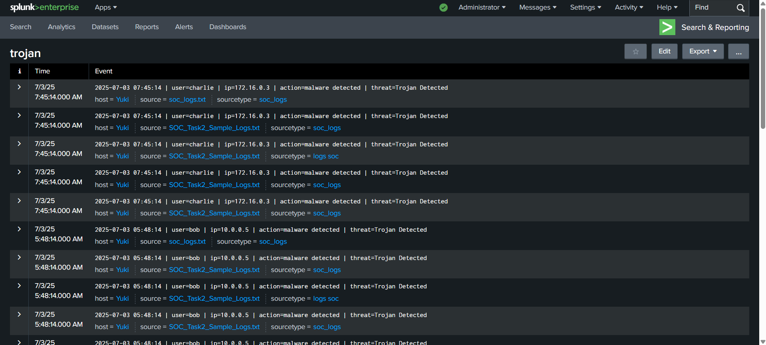
The screenshot below shows a Trojan malware detection on Charlie’s device, as recorded by the SIEM tool. This alert was classified as medium priority due to its potential to spread across the network.

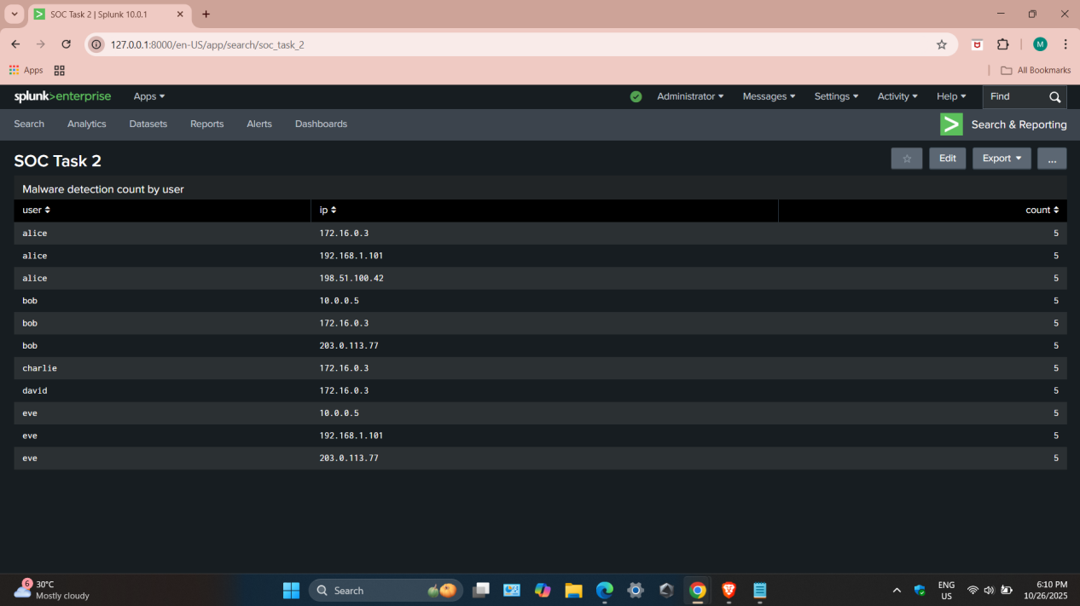
Malware count dashboard

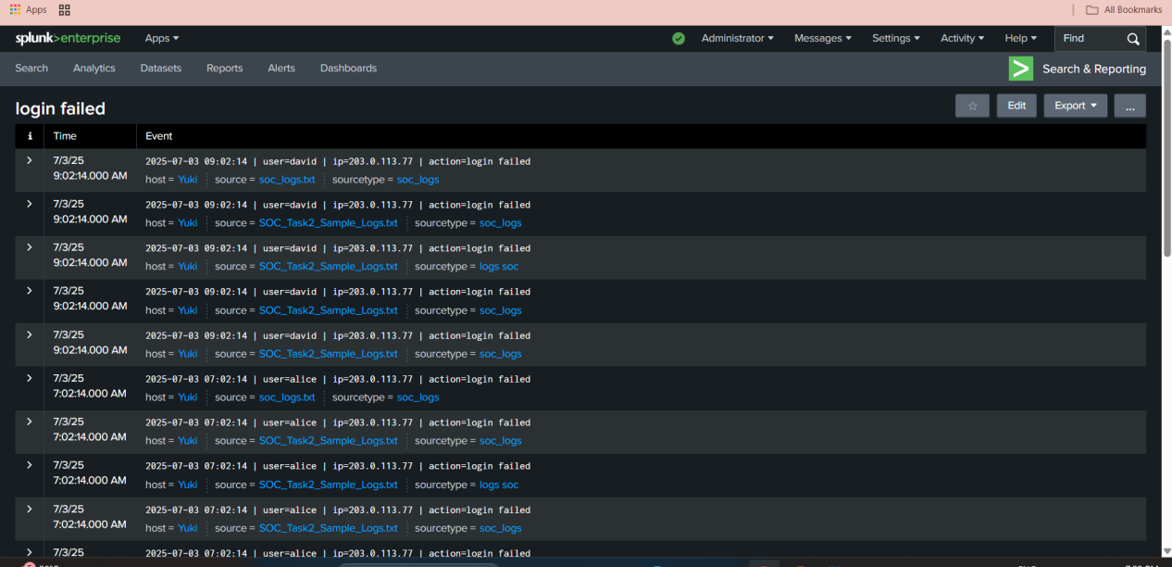
There were multiple failed login attempts detected during the monitoring period. These failed logins could indicate potential brute force attempts or unauthorized access attempts on user accounts.

Conclusion

During this task, I monitored logs and spotted suspicious activities like failed logins and malware alerts. High-priority threats such as Ransomware were flagged, and medium threats like Trojans were noted. This exercise helped me understand how SOC teams detect, classify, and respond to security incidents.

